Morfa Bay Adventure - Equipment List
The following list is the equipment that your child will require for their stay in Morfa Bay on March 16th-18th 2022.
On the first day they will need a packed lunch to eat on arrival. Please put this in a carrier bag and wrap the food in foil or clingfilm so it can all be thrown in the bin once eaten.
- Sleeping bag
- Pillow in a pillowcase
- A waterproof/insulated coat (for wet/cold weather conditions)
- 2 x sweatshirts/jumpers
- 2 x joggers/tracksuit bottoms (jeans are not ideal)
- 2 x pairs of trainers (one old pair for the assault course)
- Flip flops/sliders or pool/wetsuit shoes (essential for sea activities)
- 2 x shorts
- 2 x t-shirts
- 2 x towels
- Muddy assault course clothes – old trousers, old t-shirt and old jumper, old trainers (these will get very muddy so ensure your child knows which outfit to put on for the muddy assault course)
- Gloves and woolly hat (for cold weather)
- Underwear and socks
- Pyjamas/onesie
- Toilet bag and toiletries
- Swimming costume (2 if possible)
- 2 x black bin liners (one for muddy clothes, one for wet clothes)
- One water bottle
- One hot drinks mug for hot chocolate in the evening (preferable unbreakable)

Following the muddy assault course, clothing/footwear will be left in a designated drying area for each individual school. Once dry it needs to be collected and put in a black bag to take home on the final day.
N.B. IT IS IMPORTANT THAT ALL CLOTHING IS LABELLED AS MORFA BAY ADVENTURE CANNOT BE HELD RESPONSIBLE FOR ANY MISLAID OR LOST ITEMS.
- Pupils attending may bring books and magazines. Such items should only be used in the dormitories or during free time and are the responsibility of the individual.
- No mobile phones or electrical devices are permitted. Accompanying staff will take photographs and tweet them regularly.
- Please leave all jewellery at home in case it is lost.
This is the itinerary for the stay:
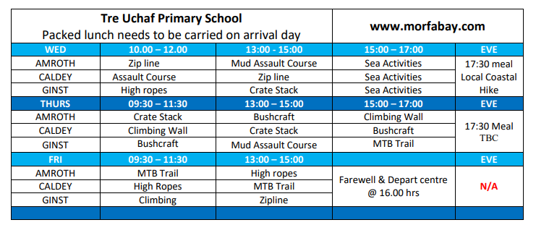

Medical Conditions
If your child has a medical condition, please complete the form below with all details that staff need to know about.
Medical Condition _____________________________________________________________________________________________________________________________________________________________________________________________________________________________________________________
Medication they need and how often;
________________________________________________________________________________________________________________________________________________________________________________________________________________________________________________________________

Any allergies:
________________________________________________________________________________________________________________________________

Any other issues you want us to know about:
________________________________________________________________________________________________________________________________________________________________________________________________________________________________________________________________

Contact Details
Please provide an up-to-date contact for the period of time 16th-18th March in case of an emergency:
First contact-
Name: ____________________________________________________
Address: ________________________________________________________________________________________________________________________________
Mobile phone number:____________________________________________
Home phone number: ____________________________________________
Work phone number: ____________________________________________
Relationship to child: _____________________________________________

Second contact:
Name: ____________________________________________________
Address: ________________________________________________________________________________________________________________________________
Mobile phone number:____________________________________________
Home phone number: ____________________________________________
Work phone number: ____________________________________________
Relationship to child: _____________________________________________

